Ride Analysis Report(Excel)
Name: Maitreyee Khachane
Course: Data Analytics
Batch: CX-167-MOR-JAN-OFFLINE

OBJECTIVE: To analyse ride data and identify patterns in service usage, revenue generation, customer behaviour, and demand trends.

DATASET DESCRIPTION:
Columns | Meaning
services | Type of ride (cab economy, auto, bike, bike lite, parcel)
date | Ride date
time | Ride start time
ride_status | Completed / Cancelled
source | Pickup location
destination | Drop location
duration | Ride duration in minutes
ride_id | Unique ride identifier
distance | Distance traveled (km)
ride_charge | Base fare
misc_charge | Extra charges (toll, waiting, etc.)
total_fare | Final amount paid
payment_method | Mode of payment
Average fare | Average fare for all rides
Fare increase | What-if analysis for fare increase
Demand drop | Revenue when ride demand drops

DATA CLEANING AND ANALYSIS
DATA CLEANING:
- Ensured proper formatting of date and time fields.
- Checked for missing or inconsistent values.
- Verified numerical columns such as fare, distance, and duration.
- Structured and organised data for pivot table analysis.

ANALYSIS PERFORMED:

- Service-wise ride count and revenue analysis
- Monthly and daily revenue trend analysis
- Peak ride time identification
- Payment method distribution
- Route frequency analysis (Source → Destination)
- Fare anomaly detection
- Profit calculation using the assumed cost per km
- What-if analysis and demand drop simulation

DASHBOARD

DESCRIPTION: An interactive dashboard was created using pivot tables to visualise key performance metrics such as revenue, ride distribution, trends, and service performance. Slicers were used to make the dashboard interactive and allow dynamic filtering.

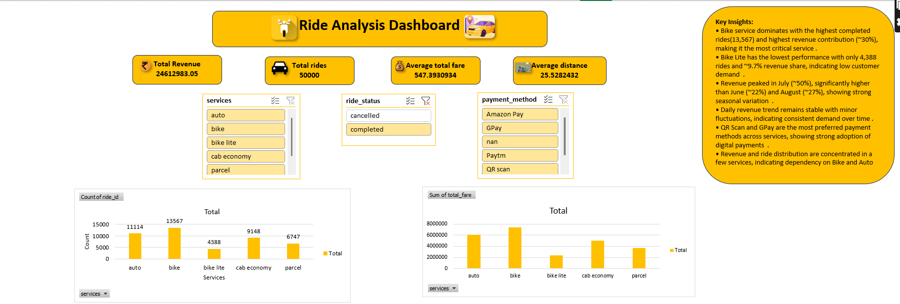
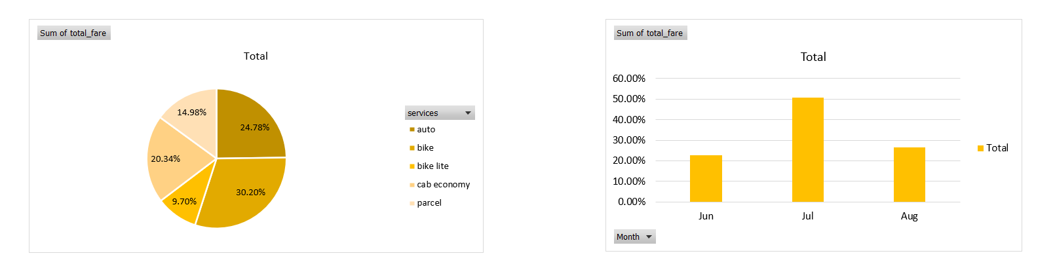
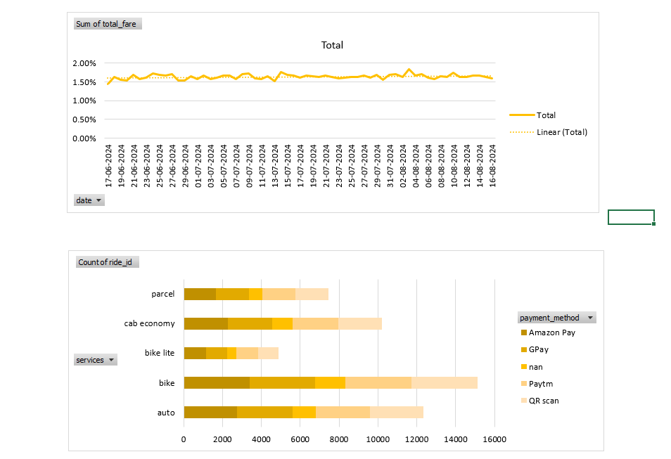

KEY INSIGHTS:
• Bike service dominates the business with the highest ride volume (13,567) and highest revenue contribution (~30%).
• Bike Lite has the lowest performance with only 4,388 rides and ~9.7% revenue share, indicating low customer demand.
• Revenue peaked in July (~50%), compared to June (~22%) and August (~27%), showing strong seasonal variation.
• Daily revenue trend remains stable with minor fluctuations, indicating consistent demand over time.
• QR Scan and GPay are the most preferred payment methods across services.
• Revenue and ride distribution are concentrated in a few services, indicating dependency on Bike and Auto.

CONCLUSION:

The analysis shows that ride demand and revenue are concentrated in specific services, particularly Bike and Auto. Revenue trends indicate seasonal variation, while daily performance remains stable.

RECOMMENDATIONS:
- Improve performance of low-demand services like Bike Lite and Parcel.
- Optimise pricing strategies for high-demand services.
- Focus on expanding popular payment methods like QR Scan and GPay.
- Analyse high-frequency routes for better resource allocation.

